A comparison of butterfly abundances and predation rates of clay caterpillars on an island without birds to two islands with birds

Alexandra Kerr and Jasmin Silva

Introduction

Top-down control of herbivorous arthropods by birds is well documented in a variety of ecosystems: neotropical forests, temperate forests, and agrosystems (Van Bael et al. 2003, Marquis and Whelan 1994, Greenberg et al. 2000). Typically, a manipulative experiment is used where netting is set up to exclude birds from the experimental site and arthropod abundance and herbivory damage are measured. A more novel, but no less successful tool for measuring predation involves the use of clay models. Clay caterpillars can be used to test relative predation rates between different types of habitat, such as understory versus canopy, forest edge versus forest interior, or disturbed vs. undisturbed habitat (Richards and Coley 2007, Koh and Menge 2006, Loiselle and Farje-Brenner 2002, Posa et. al 2007).

Guam, The southernmost island of the Marianas chain, presents a unique situation to test the theory of top-down control. Due to the introduction of the invasive Brown tree snake (*Boiga irregularis*) after WWII, all native forest birds are now functionally extinct. By 1998, 12 of Guam’s 25 birds (18 of which are native) were extirpated and 8 more had experienced population declines of more than 90% (Savidge 1987, Wiles et al. 2003). The food web on Guam has drastically altered since the introduction of the brown tree snake, with fairly rapid negative impacts on bird populations, as well as on reptile and small mammal populations (Fritts and Rodda 1998). In contrast, all other islands of the Marianas still maintain populations of native forest birds. The impact of bird loss on an arthropod population on Guam has recently been studied. The spider population on Guam is significantly greater than on neighboring islands with birds, indicating the spider’s release from top-down control by birds (Rogers et al. 2012). Other potential negative impacts have been proposed for local agriculture as well as the potential for easier establishment of exotic arthropods introduced to Guam, but these effects have not been studied (Fritts and Rodda 1998).

To test whether there is top-down control of butterflies, we asked two questions: (1) Does the removal of a top predator, specifically insect-eating birds, increase the abundance of butterflies? (2) Is there a lower predation rate of caterpillars on Guam, where birds are extinct, than on Saipan and Rota? We hypothesize that birds exert top-down control on butterfly populations, so butterfly abundance will be higher on Guam than on Saipan and Rota, and predation rates on caterpillars will therefore be lower on Guam. To test the mechanism for this hypothesis, clay caterpillars were placed along transects on all three islands in two types of habitat, disturbed forest of mainly *Leucaena leucocephala* and native limestone forest. Butterfly surveys were conducted at several sites of the two aforementioned habitat types on all islands based on a standard Pollard walk (Pollard 1977, Caldas and Robbins 2003, Walpole and Sheldon 1999). Caterpillar predation rates and butterfly abundance were then compared between Guam, with no birds, and the two islands, Saipan and Rota, with birds.

Methods

Study Sites-- Surveys and experiments were conducted on three of the four southernmost islands of the Mariana Islands chain: Guam, Rota, and Saipan. The Mariana Islands are mainly volcanic with large areas of limestone uplift (Mueller-Dombois and Fosberg 1998). Forests found on these limestone uplifts originally dominated the vegetation of these islands (Mueller-Dombois and Fosberg 1998). Although differences in limestone forest vegetation and species abundance and dominance exist among the three islands, limestone forests in general can be characterized by plant species such as *Pandanus tectorius and P. dubius*, *Guamia mariannae*, *Cynometra ramiflora*, *Pisonia grandis*, *Neisosperma oppositifolia*, *Ochrosia mariannensis*, *Artocarpus mariannensis, Eugenia spp.,* and *Ficus prolixa* (Mueller-Dombois and Fosberg 1998). On Guam and Rota, a naturalized citrus plant, *Triphasia trifolia* is also found in various habitats. All three islands have been disturbed due to human development, though less so on Rota. Disturbed areas include large stands of *Leucaena leucocephala*, a naturalized leguminous tree (Raulerson and Rinehart 1991).

If possible, established hiking trails or coconut crab hunter trails were used, otherwise a trail was cleared. Each trail was 219-300 m long. Areas in Guam and Rota with high densities of *T. trifolia* were avoided as it is not established on Saipan, and its presence attracts the butterfly P. polytes, which could bias results for Guam and Rota.

Clay Caterpillar Experiment—The experiment was done in June and July of 2013. A total of 6 native forest sites (Guam n=2, Rota n=2, Saipan n=2) and 5 disturbed *L. leucocephala* sites (Guam n=2, Rota n=2, Saipan n=1) were chosen. Clay caterpillars were made out of Green Sargent Art ® modeling clay, loosely modeled after the larvae of *Eurema blanda*, a Large Grass Yellow butterfly present on Guam, Rota and Saipan. Models were hand-shaped to 3x30mm. Care was taken to leave no marks on the clay. 150 caterpillars were made for each site and placed 1-2 m above ground on both sides of the trail. Caterpillars were placed at least 2 m from each other. Caterpillar placement was alternated between stem and leaf to test for variability in substrate choice. Caterpillars were exposed for 48 hrs, and all caterpillars that were predated or suspected to be predated were recorded and collected in small Ziploc snack bags and placed in hard plastic containers for later inspection. Any caterpillars missing from their “perch” were searched for, and if found on the ground, inspected for predation. Predation marks were examined by microscope and grouped by type A through P. A linear mixed effects model was used to compare relative predation rates between the islands with birds and the island without birds.

Butterfly Surveys—Surveys were conducted between June and early August of 2013. A total of 11 native forest transects (Guam n=4, Rota n= 4, Saipan n= 3) and 10 disturbed *L. leucocephala* transects (Guam n=3, Rota n= 3, Saipan n= 4) were surveyed. 300m transects were measured using a hand-held GPS device. If this was not possible, due to poor reception in the understory, a measuring tape was used instead. Surveys were done between 0930 and 1500 hrs and at times of full sun or partly cloudy skies. One observer and one recorder (recording amount of butterflies and species) walked the transect at a steady pace (as close to 50 m per minute as possible). The observer only counted butterflies seen 5m to each side, 10 m in front, and up to the forest canopy. Butterflies were easily identified to species while in flight or at rest. Lepidoptera of the families Hesperiidae and Lycaenidae were not included in counts.

Results

Clay Caterpillar Experiment— Initial results show that predation rates are higher on the islands with birds than on the island without birds for both types of habitat (Fig. 1 and 2).

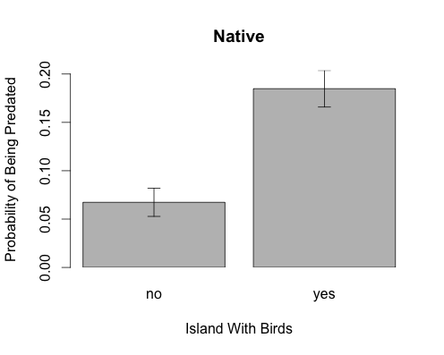

Fig. 1. A Comparison of predation probability in native forest between two islands with birds (yes) and an island without birds (no).

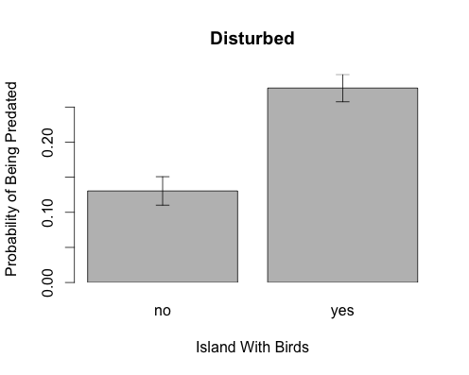

Fig. 2. A Comparison of predation probability in disturbed *L. leucana* forest between two islands with birds (yes) and an island without birds (no).

Butterfly Surveys—Initial results show that on average more butterflies were spotted on transects on Guam than on Saipan and Rota. This is true for both types of habitats.

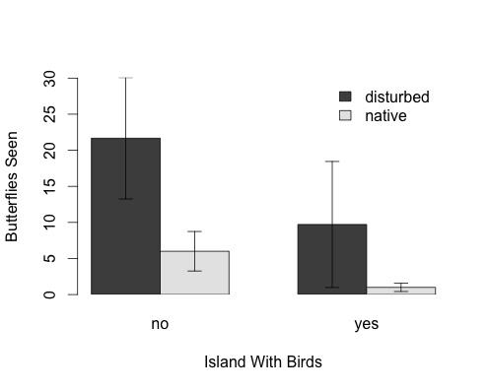

Fig. 3. A comparison of butterflies seen along transects between islands with birds (yes) and the island without birds (no) for both native and disturbed habitats.

Discussion

Although analysis is still ongoing, initial results tend to support our hypothesis. An island with birds has higher caterpillar predation than an island without birds. Additionally, an island with birds will have lower butterfly abundance than an island without birds. At the site-level, we observed a positive correlation between predation rates and butterfly abundance. This is not consistent with other findings (Koh and Menge 2006). Between habitats, disturbed *L. leucana* forests had a greater proportion of predation compared to native forests. Top-down control of arthropods may be further tested through herbivory damage surveys between islands.

We realize that clay models do not entirely replace the real animal, and therefore, results may not accurately reflect natural predation rates. For example, clay caterpillars do not move or give off chemical signals, which may help cue certain predators. However, clay models provide a quick comparative method between islands, as well as a way to test the mechanism for butterfly abundance differences between islands.

During our surveys we noticed that Guam’s forests had more gaps, and these gaps seemed to be areas where butterflies were present. In future surveys, a count of gaps along the transect would be recommended. Surveys were conducted at the beginning of the wet season, and seasonal differences in butterfly abundance might help to explain the low numbers observed on Saipan and Rota. Like spiders (Rogers et al. 2012), perhaps butterfly abundance on Guam may be released from seasonal factors. A comparison of butterfly abundances throughout the year would give a better index of abundance differences among islands.

References

Caldas A. and Robbins R.K., 2003. Modified Pollard transects for assessing tropical butterfly abundance and diversity. *Biological Conservation*. 110: 211-219.

Fritts T.H. and Rodda G.H., 1998. The role of introduced species in the degradation of island ecosystems: A case history of Guam. *Annual Review of Ecological Systems*. 29: 113-40.

Greenberg R., Bichier P., Angon A.C., MacVean C., Perez R., and Cano E., 2000. The impact of avian insectivory on arthropods and leaf damage in some Guatemalan coffee plantations.  *Ecology*, 81(6): 1750-1755.

Koh L.P. and Menge D. N. L., 2006. Rapid assessment of Lepidoptera predation rates in neotropical forest fragments. *Biotropica*. 38(1): 132-134.

Loiselle B.A. and Farje-Brenner A. G., 2002. What’s up? An experimental comparison of predation levels between canopy and understory in a tropical wet forest. *Biotropica*. 34(2): 327-330.

Marquis R.J. and Whelan C. J, 1994. Insectivorous birds increase growth of white oak through consumption of leaf-chewing insects. *Ecology*. 75(7): 2007-2014.

Pollard E., 1977. A method for assessing changes in the abundance of butterflies. *Biological Conservation*. 12(2): 115-134.

Posa M. R., Sodhi N.S., and Koh L.P., 2007. Predation on artificial nests and caterpillar models across a disturbance gradient in Subic Bay, Philippines. *Journal of Tropical Ecology*. 23(1): 27-33.

Richards L.A. and Coley P. D., 2007. Seasonal nd habitat differences affect the impact of food and predation on herbivores: a comparison between gaps and understory of a tropical forest. *Oikos*. 116: 31-40.

Rogers H., Hille Ris Lambers J., Miller R., Tewksbury J.J., 2012. ‘Natural experiment’ Demonstrates Top-Down Control of Spiders by Birds on a Landscape Level. *PLoS ONE*. 7(9): e43446. doi:10.1371/journal.pone.0043446.

Savidge J.A., 1987. Extinction of an island forest avifauna by an introduced snake. *Ecology*. 68(3): 660-668.

Van Bael S.A., Brawn J.D., and Robinson S.K., 2003. Birds defend trees from herbivores in a neotropical forest canopy. *PNAS*. 100(14): 8304-8307.

Walpole M. J. and Sheldon I.R., 1999. Sampling butterflies in tropical rainforests: an evaluation of a transect walk method. *Biological Conservation*. 87: 85-91.

Wiles G. J., Bart J., Beck Jr. R. E., Aguon C.F., 1998. Impacts of the brown tree snake: patterns of decline and species persistence in Guam’s avifauna. *Conservation Biology*. 17(5): 1350-1360.